CI204 DATABASES II ASSIGNEMENT 2

University of Brighton |

John Vos

2019

Contents

Table Booking: 4

SQL Statements: 4

Create table: 4

Insert into: 4

Table Staff: 0

SQL Statements: 0

Create table: 0

Insert into: 0

Table Staff Booking: 0

SQL Statements: 0

Create table: 0

Insert into: 0

Table Staff Pay: 2

SQL Statements: 2

Insert Into: 2

Table Event Details: 3

SQL Statements: 3

Create table: 3

Insert into: 3

Table Event Contact Details: 0

SQL Statements: 0

Create table: 0

Insert into: 0

Table Truck: 0

SQL Statements: 0

Create table: 0

Insert into: 0

Table Truck Booking: 1

SQL Statements: 1

Create table: 1

Insert into: 1

Table Accident Log: 3

SQL Statements: 3

Create table: 3

Insert into: 3

Table Recipe: 0

SQL Statements: 0

Create table: 0

Insert into: 0

Table Ingredients: 1

SQL Statements: 1

Create table: 1

Insert into: 1

Table Recipe Ingredients: 0

SQL Statements: 0

Create table: 0

Insert into: 0

Table Ingredients to Recipe: 2

SQL Statements: 2

Create table: 2

Insert into: 2

Must: 3

1. Record /edit/cancel bookings for multiple trucks at outdoor events 3

Record booking: 3

Edit booking: 4

Cancel booking: 5

2. For all staff, ensure that a level 2 food hygiene certificate is in place 6

3. For each item sold, produce a list of ingredients 7

4. Identify all truck bookings for any given date 8

5. Identify all bookings for a given truck 9

Should: 10

6. Record any accidents / reportable incidents that take place, including the event at which they happened 10

7. For all staff acting as supervisors, ensure that a level 3 food hygiene certificate is in place 11

8. For all events involving alcohol, identify a team member as the license holder. 0

9. Identify any temporary staff who are not currently working this weekend (i.e. may be available for a last- minute booking). 1

Could: 2

10. Record members of staff who worked at specific events, including who was acting as the supervisor. This should include the number of hours worked by each staff member, and their rate of pay. 2

11. Produce a list of ingredients for each item sold, with known allergens at the top of the list - this should include sub-ingredients, like the tahini ingredients on the hummus recipe described previously. 0

Would be nice if: 1

12. Identify weekends in the next month with available trucks (to offer last minute deals) 1

Functionality: 2

PART 1) 2

PART 2) 2

PART 3) 3

Create a simple application to provide an interface capable of executing the above functionality (select queries and procedures): 4

ERD: 7

# Table Booking:

## SQL Statements:

### Create table:

CREATE TABLE tbl_booking (

booking_ID int NOT NULL,

event_ID int NOT NULL,

booking_name varchar(50) NOT NULL,

booking_date date NOT NULL,

booking_duration int NOT NULL,

repeat_event bit,

PRIMARY KEY (booking_ID),

FOREIGN KEY (event_ID) REFERENCES tbl_event_details(event_ID)

);

### Insert into:

/*inserts 10 cells of data into booking*/

INSERT INTO tbl_booking(booking_ID, event_ID, booking_name, booking_date, booking_duration, repeat_event)

VALUES

(1, 1, 'Fuss - Budget Wedding', '2019-03-15', 1, 0),

(2, 2, 'Lewes Farmers Market', '2019-03-01', 1,1),

(3, 3, 'Brighton Grande Parade', '2019-04-22', 3, 1),

(4, 4, 'Lewes Farmers Market', '2019-04-01', 1, 1),

(5, 5, 'Carl Birthday Party', '2019-05-16', 1, 0),

(6, 6, 'Boss - Wedding', '2019-05-16', 2, 0),

(7, 7, 'Susan Birthday Party', '2019-05-30', 1, 0),

(8, 8, 'Lewes Farmers Market', '2019-05-01', 1, 1),

(9, 9, 'Brighton Pier Easter', '2019-04-21', 1, 0),

(10, 10, 'Brighton Pier Halloween', '2019-11-30', 1, 1);

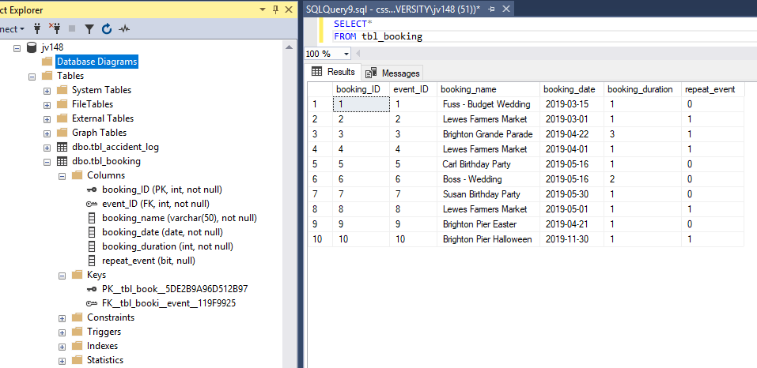

# Table Staff:

## SQL Statements:

### Create table:

CREATE TABLE tbl_staff(

staff_ID int NOT NULL,

staff_first_name varchar(50) NOT NULL,

staff_second_name varchar(50) NOT NULL,

staff_email varchar(50) NOT NULL,

comments varchar(50),

alcohol_vending_licence bit NOT NULL,

food_hygiene_certificate bit NOT NULL,

food_hygiene_certificate_level int NOT NULL,

PRIMARY KEY (staff_ID),

);

### Insert into:

/* inserts 10 cells of data into staff*/

INSERT INTO tbl_staff(staff_ID, staff_first_name, staff_second_name, staff_email, comments, alcohol_vending_licence, food_hygiene_certificate, food_hygiene_certificate_level)

VALUES

(1, 'John', 'Vos', 'staff1email.com', 'cannot work sundays', 1, 1, 2),

(2, 'James', 'Shaw', 'staff2email.com', NULL, 1, 1, 2),

(3, 'Jack', 'Whitchurch', 'staff3email.com', 'cannot handle nuts, allergic', 1, 1, 2),

(4, 'Ross', 'Jones', 'staff4email.com', NULL, 1, 1, 2),

(5, 'Susan', 'Betsy', 'staff5email.com', NULL, 1, 1, 2),

(6, 'Andy', 'Chong', 'staff6email.com', 'staff in training', 1, 1, 2),

(7, 'Bob', 'Pop', 'staff7email.com', NULL, 1, 1, 2),

(8, 'Paul', 'The second', 'staff8email.com', NULL, 1, 1, 2),

(9, 'Alfred', 'Son of person', 'staff9email.com', NULL, 1, 1, 2),

(10, 'Worker', 'Number two', 'staff10email.com', NULL, 1, 1, 2);

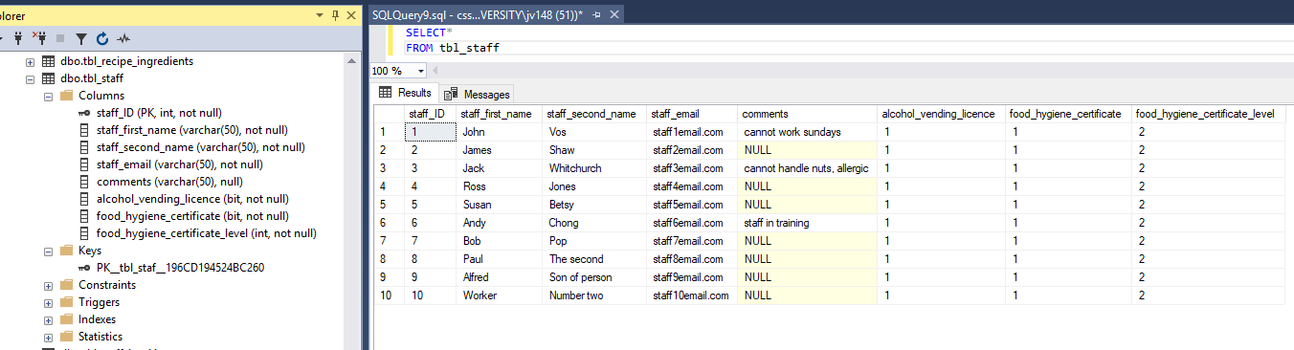

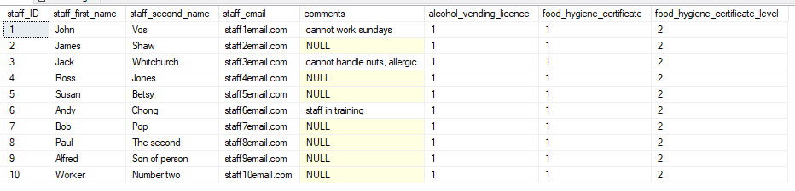

# Table Staff Booking:

## SQL Statements:

### Create table:

CREATE TABLE tbl_staff_booking(

staff_ID int NOT NULL,

booking_ID int NOT NULL,

staff_hours int NOT NULL,

staff_role varchar(15),

alcohol_vending_licence bit,

PRIMARY KEY (staff_ID, booking_ID),

FOREIGN KEY (staff_ID) REFERENCES tbl_staff(staff_ID),

FOREIGN KEY (booking_ID) REFERENCES tbl_booking(booking_ID),

FOREIGN KEY (staff_role) REFERENCES tbl_staff_pay(staff_role)

);

### Insert into:

/* inserts 10 cells of data into staff booking*/

INSERT INTO tbl_staff_booking(staff_ID, booking_ID, staff_hours, staff_role, alcohol_vending_licence)

VALUES

(1, 1, 8, 'supervisor', 1),

(2, 1, 8, 'supervisor', 0),

(3, 2, 6, 'supervisor', 0),

(3, 3, 8, 'staff', 1),

(4, 3, 8, 'staff', 0),

(5, 4, 8, 'staff', 0),

(6, 5, 8, 'staff', 0),

(7, 6, 8, 'supervisor', 1),

(8, 7, 8, 'supervisor', 1),

(9, 8, 8, 'staff', 0),

(10, 9, 8, 'staff', 1),

(10, 10, 8, 'staff', 1);

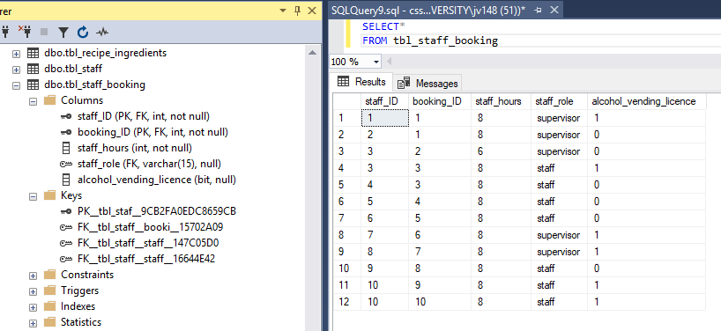

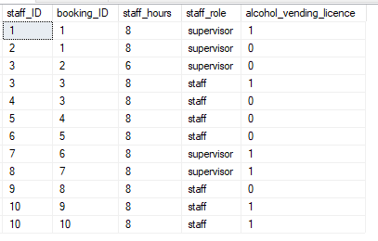

# Table Staff Pay:

## SQL Statements:

CREATE TABLE tbl_staff_pay (

staff_role varchar(15) NOT NULL,

rate_of_pay smallmoney NOT NULL,

PRIMARY KEY(staff_role),

)

## Insert Into:

INSERT INTO tbl_staff_pay (staff_role, rate_of_pay)

VALUES

('supervisor', 7.25*1.2),

('staff', 7.25);

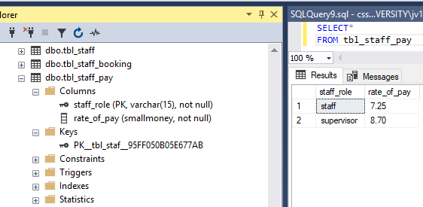

# Table Event Details:

## SQL Statements:

### Create table:

CREATE TABLE tbl_event_details(

event_ID int NOT NULL,

event_name varchar(50) NOT NULL,

start_time time NOT NULL,

event_address_1 nvarchar(50) NOT NULL,

event_address_2 nvarchar(50),

event_post_code nvarchar(8) NOT NULL,

event_type varchar(2) NOT NULL,

number_of_covers int,

alcohol_present bit,

PRIMARY KEY (event_ID),

);

### Insert into:

/*inserts 10 cells of data into event_details*/

INSERT INTO tbl_event_details(event_ID, event_name, start_time, event_address_1, event_address_2, event_post_code, event_type, number_of_covers, alcohol_present)

VALUES

(1, 'ABCD Road', '09:00:00', 'ABCD Road', 'Somewhere', 'UW8 9EP', 'OC', 200, 1),

(2, 'Cliffe High St', '06:30:00', 'Cliffe High St', 'Lewes', 'BN7 2AP', 'DS', NULL, 0),

(3, 'Brighton Grande Parade', '10:30:00', 'LOPK Street', 'Elsewhere', 'POO 1IK', 'DS', NULL,1),

(4, 'Lewes Farmers Market', '06:30:00', 'Cliffe High St', 'Lewes', 'BN7 2AP', 'DS', NULL, 1),

(5, 'Carl Birthday Party', '11:00:00', 'QWERTY blv', 'Everywhere', 'KR3 ST5', 'OC', 25, 1),

(6,'Boss - Wedding', '09:00:00', 'Wedding venue', 'Wonderland', 'H5T JN8', 'OC', 400, 0),

(7, 'Susan Birthday Party', '11:00:00', 'Birthday Venue', 'LALALAND', 'LM0 4FR', 'OC', 50, 0),

(8,'Lewes Farmers Market', '06:30:00', 'Cliffe High St', 'Lewes', 'BN7 2AP', 'DS', NULL, 0),

(9,'Brighton Pier Easter', '14:00:00', ' Madeira DR', 'Brighton', 'BN2 1TW', 'DS', NULL, 1),

(10,'Brighton Pier Halloween', '21:00:00', ' Madeira DR', 'Brighton', 'BN2 1TW', 'DS', NULL, 1);

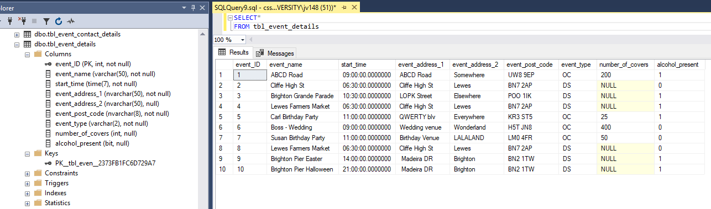

# Table Event Contact Details:

## SQL Statements:

### Create table:

CREATE TABLE tbl_event_contact_details(

event_ID int NOT NULL,

event_contact_name varchar(50) NOT NULL,

event_contact_tel_numb char(10) NOT NULL,

event_contact_email varchar(40) NOT NULL,

PRIMARY KEY (event_ID),

FOREIGN KEY (event_ID) REFERENCES tbl_event_details(event_ID)

);

### Insert into:

/* inserts 10 cells of data into staff booking*/

INSERT INTO tbl_event_contact_details(event_ID, event_contact_name, event_contact_tel_numb, event_contact_email)

VALUES

(1, 'rogan fuss', 07700900597, 'evencontact1@mail.com'),

(2, 'trey parks', 07700900029, 'evencontact2@mail.com'),

(3, 'alaya ahmad', 07632960579, 'evencontact3@mail.com'),

(4, 'trey parks', 07700900029, 'evencontact4@mail.com'),

(5, 'lochlan gardner', 07632960395, 'evencontact5@mail.com'),

(6, 'krishan collins', 07632605791, 'evencontact6@mail.com'),

(7, 'aairah carty', 07025550154, 'evencontact7@mail.com'),

(8, 'trey parks', 07036254198, 'evencontact8@mail.com'),

(9, 'amba ruiz', 07700900597, 'evencontact9@mail.com'),

(10, 'kady chapman', 07235941054, 'evencontact10@mail.com');

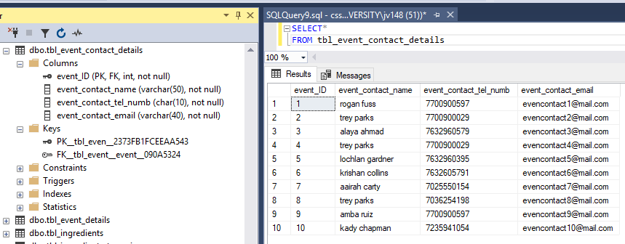

# Table Truck:

## SQL Statements:

### Create table:

CREATE TABLE tbl_truck(

truck_ID varchar(4) NOT NULL,

truck_VIN varchar(17) NOT NULL,

PRIMARY KEY (truck_ID),

);

### Insert into:

/*inserts 5 cells of data into truck*/

INSERT INTO tbl_truck(truck_ID, truck_VIN)

VALUES

('YUM1', 'D4T4B4SES1SH4RD45'),

('YUM2', 'MAGICCHEESEB00T1E'),

('YUM3', 'G4RL1CBR34DSTICK5'),

('YUM4', 'H1DDENM3SS4G3SYUP'),

('YUM5', '1TH1NK1MSOFUNNYH4');

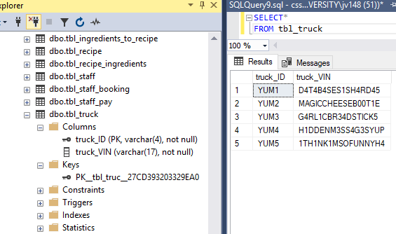

# Table Truck Booking:

## SQL Statements:

### Create table:

CREATE TABLE tbl_truck_booking(

truck_ID varchar(4) NOT NULL,

booking_ID int NOT NULL,

recipe_ID VARCHAR(3) NOT NULL,

booking_date date NOT NULL,

PRIMARY KEY (truck_ID, booking_ID, recipe_ID),

FOREIGN KEY (truck_ID) REFERENCES tbl_truck(truck_ID),

FOREIGN KEY (recipe_ID) REFERENCES tbl_recipe(recipe_ID),

FOREIGN KEY (booking_ID) REFERENCES tbl_booking(booking_ID)

);

### Insert into:

INSERT INTO tbl_truck_booking(truck_ID, booking_ID, recipe_ID, booking_date)

VALUES

('YUM1', 1, 'HF1', '2019-03-15'),

('YUM1', 1, 'HF2', '2019-03-15'),

('YUM2', 1, 'HT6', '2019-03-15'),

('YUM2', 1, 'JS1', '2019-03-15'),

('YUM3', 2, 'CK6', '2019-03-01'),

('YUM3', 2, 'VB1', '2019-03-01'),

('YUM4', 3, 'VT1', '2019-04-22'),

('YUM4', 3, 'LM3', '2019-04-22'),

('YUM1', 4, 'PC3', '2019-04-01'),

('YUM1', 4, 'VM7', '2019-04-01'),

('YUM2', 5, 'HF1', '2019-05-16'),

('YUM2', 5, 'HF2', '2019-05-16'),

('YUM3', 6, 'HT6', '2019-05-16'),

('YUM3', 6, 'JS1', '2019-05-16'),

('YUM4', 7, 'CK6', '2019-05-30'),

('YUM4', 7, 'VB1', '2019-05-30'),

('YUM1', 8, 'VT1', '2019-05-01'),

('YUM1', 8, 'LM3', '2019-05-01'),

('YUM2', 9, 'PC3', '2019-04-21'),

('YUM2', 9, 'VM7', '2019-04-21'),

('YUM3', 10, 'HF1', '2019-11-30'),

('YUM3', 10, 'HF2', '2019-11-30');

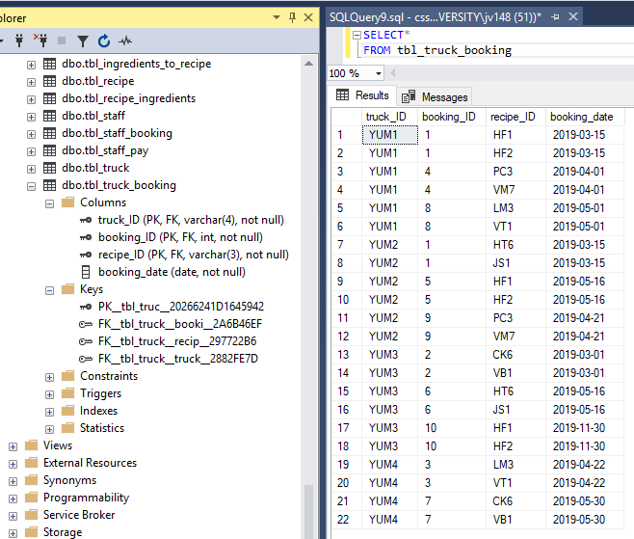

# Table Accident Log:

## SQL Statements:

### Create table:

CREATE TABLE tbl_accident_log(

accident_ID int NOT NULL,

booking_ID int NOT NULL,

staff_ID int NOT NULL,

date_of_incident date NOT NULL,

date_reported date NOT NULL,

comments varchar(200) NOT NULL,

PRIMARY KEY (accident_ID),

FOREIGN KEY (booking_ID) REFERENCES tbl_booking(booking_ID),

FOREIGN KEY (staff_ID) REFERENCES tbl_staff(staff_ID)

);

### Insert into:

/* inserts 5 cells of data into accident log*/

INSERT INTO tbl_accident_log(accident_ID, booking_ID, staff_ID, date_of_incident, date_reported, comments)

VALUES

(1, 3, 1, '2019-03-15', '2019-04-22', 'Reversed into pole – dent in back right side bumper'),

(3, 2, 3, '2019-04-22', '2019-04-23', 'Door was damaged on left interior whilst unloading tables for event'),

(4, 9, 2, '2019-04-01', '2019-04-02', 'Van needs servicing – service due warning came up'),

(2, 7, 1, '2019-03-01', '2019-03-03', 'Right front tire flat – currently on spare tire'),

(5, 6, 4, '2019-05-16', '2019-05-16', 'Wind screen washer fluid needs to be refiled');

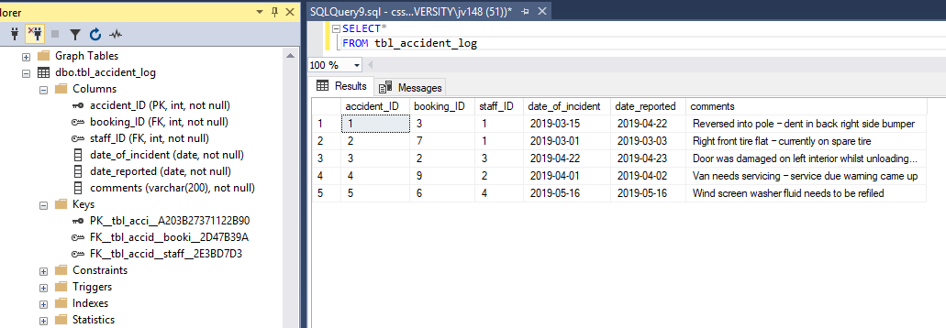

# Table Recipe:

## SQL Statements:

### Create table:

CREATE TABLE tbl_recipe(

recipe_ID varchar(3) NOT NULL,

recipe_name varchar(40) NOT NULL,

PRIMARY KEY (recipe_ID),

);

### Insert into:

/*inserts 10 cells of data into recipe*/

INSERT INTO tbl_recipe(recipe_ID, recipe_name)

VALUES

('HF1', 'hummus falafel wrap'),

('HF2', 'falafel and tabbouleh'),

('HT6', 'tabbouleh roasted veg'),

('JS1', 'apple and banana smoothie'),

('CK6', 'evening cocktails'),

('VB1', 'veggie breakfast'),

('VT1', 'roasted veg and tahini sauce'),

('LM3', 'lemonade'),

('PC3', 'pancake'),

('VM7', 'vanilla milkshake');

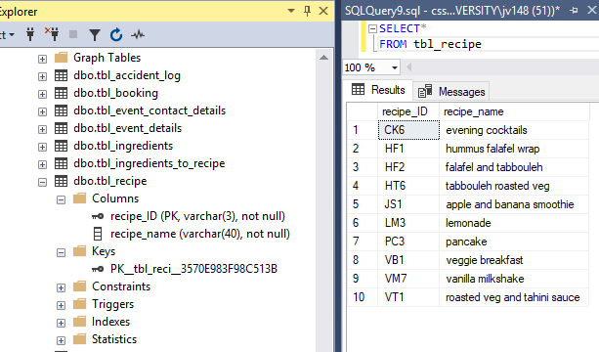

# Table Ingredients:

## SQL Statements:

### Create table:

CREATE TABLE tbl_ingredients(

ingredient_ID int NOT NULL,

contains_allergen bit NOT NULL,

ingredient varchar(200) NOT NULL,

PRIMARY KEY (ingredient_ID)

);

### Insert into:

/*inserts 28 cells of data into ingredients*/

INSERT INTO tbl_ingredients(ingredient_ID, contains_allergen , ingredient)

VALUES

(1, 1, 'cereal (wheat, rye, barely, oats)'),

(2, 1, 'crustaceans (prawns, lobster, and crayfish)'),

(3, 1, 'eggs'),

(4, 1, 'fish'),

(5, 1, 'peanuts'),

(6, 1, 'soybeans'),

(7, 1, 'milk (including lactose)'),

(8, 1, 'nuts (almonds, hazelnuts, walnuts, cashews, pecan nuts, brazil nuts, pistachio nuts, and macadamia)'),

(9, 1, 'celery (including celeriac)'),

(10, 1, 'mustard'),

(11, 1, 'sesame'),

(12, 1, 'sulphur dioxide / sulphites, where added and at a level above 10mg/kg or 10mg/L in the finished product. This can be used as a preservative in dried fruit'),

(13, 1, 'lupin, which includes lupin seeds and flour and can be found in types of bread, pastries and pasta'),

(14, 1, 'molluscs like, mussels, whelks, oysters, snails and squid'),

(15, 0, 'tahini'),

(16, 0, 'banana'),

(17, 0, 'chicken breast'),

(18, 0, 'lemon'),

(19, 0, 'cayenne pepper'),

(20, 0, 'sesame seeds'),

(21, 0, 'lamb mince'),

(22, 0, 'thyme'),

(23, 0, 'olive oil'),

(24, 0, 'za''tar'),

(25, 0, 'chickpeas'),

(26, 0, 'tabbouleh'),

(27, 0, 'sumac'),

(28, 0, 'sugar');

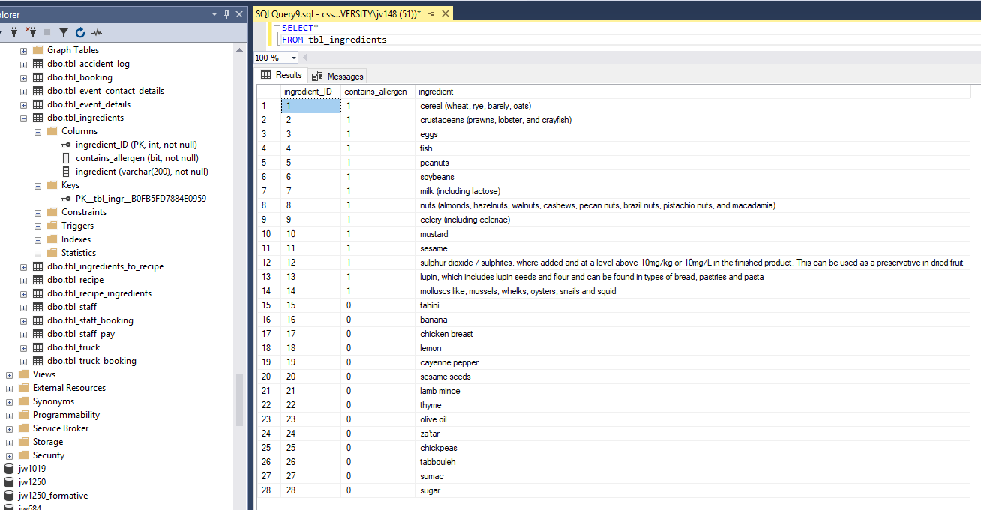

# Table Recipe Ingredients:

## SQL Statements:

### Create table:

CREATE TABLE tbl_recipe_ingredients(

ingredient_ID int NOT NULL,

recipe_ID varchar(3) NOT NULL,

quantity varchar(15) NOT NULL,

PRIMARY KEY (ingredient_ID, recipe_ID),

FOREIGN KEY (ingredient_ID) REFERENCES tbl_ingredients(ingredient_ID),

FOREIGN KEY (recipe_ID) REFERENCES tbl_recipe(recipe_ID)

);

### Insert into:

/*inserts 31 cells of data into recipe ingredients*/

INSERT INTO tbl_recipe_ingredients(ingredient_ID, recipe_ID, quantity)

VALUES

(25, 'HF1', '500g'),

(23, 'HF1', '25g'),

(15, 'HF1', '1 clove'),

(19, 'HF1', '1 ground'),

(20, 'HF1', '1 pinch'),

(22, 'HF1', '1 branch'),

(25, 'HF2', '500g'),

(23, 'HF2', '25g'),

(15, 'HF2', '1 clove'),

(19, 'HF2', '1 ground'),

(20, 'HF2', '1 pinch'),

(22, 'HF2', '1 branch'),

(26, 'HF2', '2 spoons'),

(25, 'HT6', '500g'),

(23, 'HT6', '25g'),

(15, 'HT6', '1 clove'),

(19, 'HT6', '1 ground'),

(20, 'HT6', '1 pinch'),

(22, 'HT6', '1 branch'),

(27, 'JS1', '4 apples'),

(16, 'JS1', '4 bananas'),

(24, 'JS1', '500ml'),

(27, 'VB1', '2 apples'),

(16, 'VB1', '2 bananas'),

(1, 'VB1', '1 bowl'),

(25, 'VT1', '500g'),

(18, 'LM3', '4 lemons'),

(28, 'LM3', '100g sugar'),

(7, 'PC3', '500ml'),

(3, 'PC3', '2 eggs'),

(7, 'VM7', '500ml');

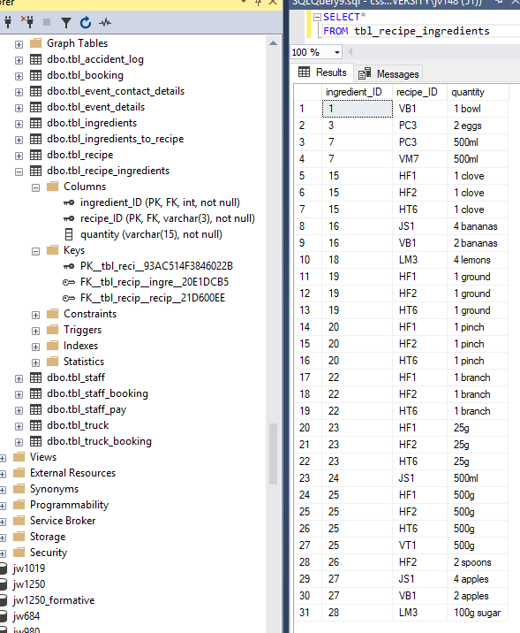

# Table Ingredients to Recipe:

## SQL Statements:

### Create table:

CREATE TABLE tbl_ingredients_to_recipe(

main_ingredient int FOREIGN KEY REFERENCES tbl_ingredients(ingredient_ID),

sub_ingredient int FOREIGN KEY REFERENCES tbl_ingredients(ingredient_ID),

quantity varchar(15) NOT NULL,

PRIMARY KEY(main_ingredient, sub_ingredient)

);

### Insert into:

INSERT INTO tbl_ingredients_to_recipe(main_ingredient, sub_ingredient, quantity)

VALUES

(15, 20, '250g'),

(15, 23, '1 cup'),

(24, 22, '1 handful'),

(24, 20, '1 tbsp'),

(24, 23, '1 cup');

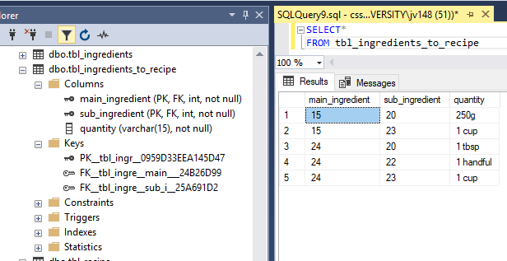

# Must:

## Record /edit/cancel bookings for multiple trucks at outdoor events

### Record booking:

INSERT INTO tbl_truck_booking(truck_ID, booking_ID, recipe_ID)

VALUES

('YUM4', 11, 'HF1');

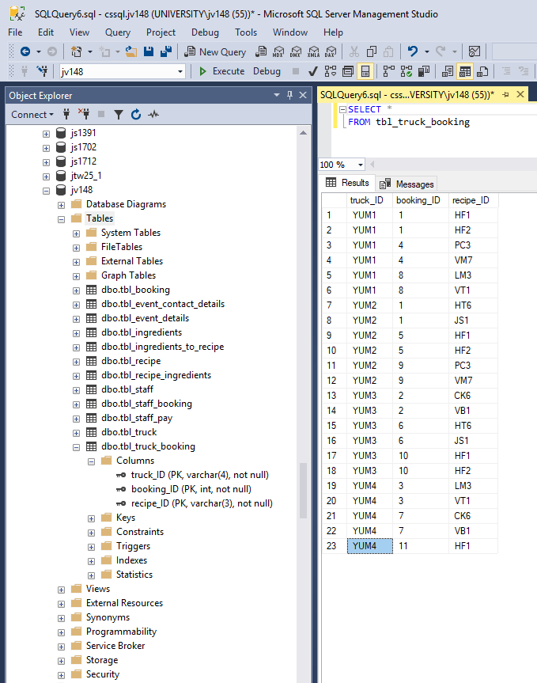

### Edit booking:

UPDATE tbl_truck_booking

SET recipe_ID = 'HF2'

WHERE

truck_ID = 'YUM4'

AND booking_ID = 3

AND recipe_ID = 'VT1'

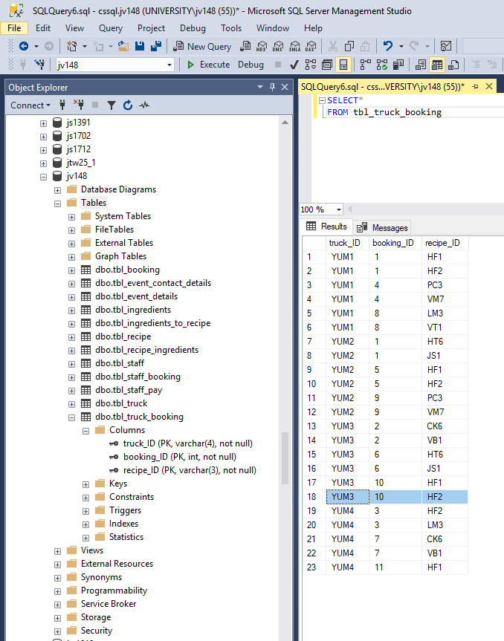

### Cancel booking:

DELETE

FROM tbl_truck_booking

WHERE truck_ID = 'YUM4'

AND booking_ID = 7

AND recipe_ID = 'CK6'

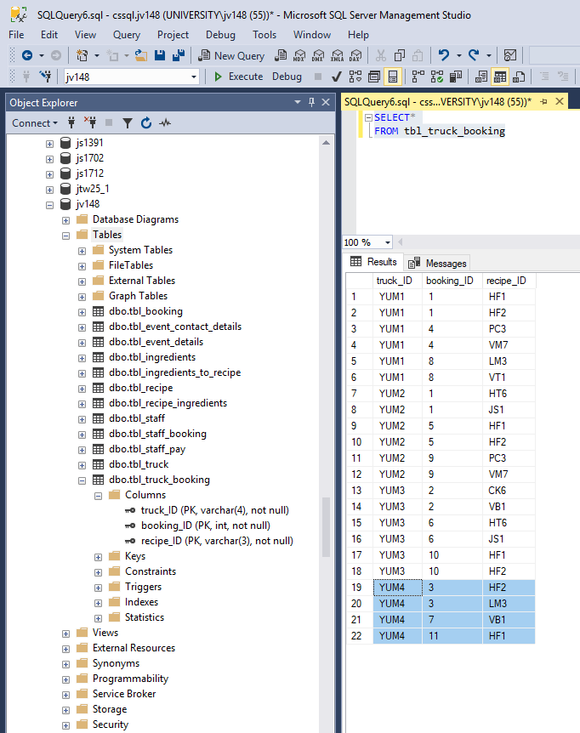

## For all staff, ensure that a level 2 food hygiene certificate is in place

CREATE TRIGGER food_hygiene_certificate

ON tbl_staff

FOR INSERT AS DECLARE @food_hygiene INTEGER

SELECT @food_hygiene = food_hygiene_certificate

FROM inserted

IF @food_hygiene < 2

BEGIN

PRINT('a food hygiene certificate level 2 or higher is required')

ROLLBACK TRANSACTION

END

INSERT INTO tbl_staff(staff_ID, staff_email, comments, alcohol_vending_licence, food_hygiene_certificate, food_hygiene_certificate_level)

VALUES

(11, 'staff11@mail.com', 'in training for food certificate', 1, 1, 0);

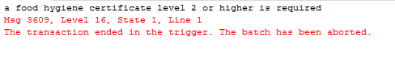

## For each item sold, produce a list of ingredients

SELECT tbl_ingredients.ingredient_ID, contains_allergen, ingredient

FROM tbl_recipe

INNER JOIN tbl_recipe_ingredients

ON tbl_recipe.recipe_ID = tbl_recipe_ingredients.recipe_ID

INNER JOIN tbl_ingredients

ON tbl_ingredients.ingredient_ID = tbl_recipe_ingredients.ingredient_ID

WHERE

tbl_recipe.recipe_ID = 'HF1'

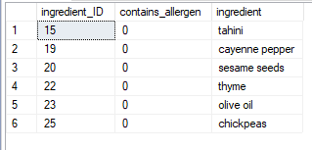

SELECT tbl_ingredients.ingredient_ID, contains_allergen, ingredient

FROM tbl_recipe

INNER JOIN tbl_recipe_ingredients

ON tbl_recipe.recipe_ID = tbl_recipe_ingredients.recipe_ID

INNER JOIN tbl_ingredients

ON tbl_ingredients.ingredient_ID = tbl_recipe_ingredients.ingredient_ID

WHERE

tbl_recipe.recipe_ID = 'VM7'

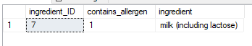

SELECT tbl_ingredients.ingredient_ID, contains_allergen, ingredient

FROM tbl_recipe

INNER JOIN tbl_recipe_ingredients

ON tbl_recipe.recipe_ID = tbl_recipe_ingredients.recipe_ID

INNER JOIN tbl_ingredients

ON tbl_ingredients.ingredient_ID = tbl_recipe_ingredients.ingredient_ID

WHERE

tbl_recipe.recipe_ID = 'HF2'

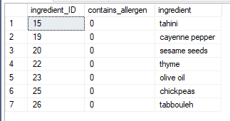

## Identify all truck bookings for any given date

SELECT tbl_truck.truck_ID, truck_VIN, tbl_booking.booking_name, tbl_event_details.event_name

FROM tbl_truck

INNER JOIN tbl_truck_booking

ON tbl_truck.truck_ID = tbl_truck_booking.truck_ID

INNER JOIN tbl_booking

ON tbl_booking.booking_ID = tbl_truck_booking.booking_ID

INNER JOIN tbl_event_details

ON tbl_booking.event_ID = tbl_event_details.event_ID

WHERE booking_date = '2019-03-01'

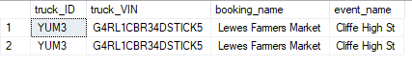

## Identify all bookings for a given truck

SELECT DISTINCT tbl_booking.booking_ID, event_name, booking_date

FROM tbl_booking

INNER JOIN tbl_event_details

ON tbl_booking.event_ID = tbl_event_details.event_ID

INNER JOIN tbl_truck_booking

ON tbl_truck_booking.booking_ID = tbl_booking.booking_ID

WHERE truck_ID = 'YUM1'

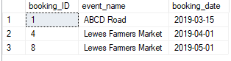

SELECT DISTINCT tbl_booking.booking_ID, event_name, booking_date

FROM tbl_booking

INNER JOIN tbl_event_details

ON tbl_booking.event_ID = tbl_event_details.event_ID

INNER JOIN tbl_truck_booking

ON tbl_truck_booking.booking_ID = tbl_booking.booking_ID

WHERE truck_ID = 'YUM2'

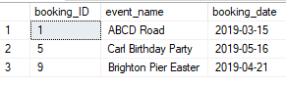

SELECT DISTINCT tbl_booking.booking_ID, event_name, booking_date

FROM tbl_booking

INNER JOIN tbl_event_details

ON tbl_booking.event_ID = tbl_event_details.event_ID

INNER JOIN tbl_truck_booking

ON tbl_truck_booking.booking_ID = tbl_booking.booking_ID

WHERE truck_ID = 'YUM3'

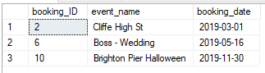

# Should:

## Record any accidents / reportable incidents that take place, including the event at which they happened

SELECT date_of_incident, tbl_staff.staff_ID, tbl_staff.staff_first_name + ' ' + tbl_staff.staff_second_name AS staff_name, event_name, tbl_staff.comments

FROM tbl_accident_log

INNER JOIN tbl_staff

ON tbl_accident_log.staff_ID = tbl_staff.staff_ID

INNER JOIN tbl_booking

ON tbl_accident_log.booking_ID = tbl_booking.booking_ID

INNER JOIN tbl_event_details

ON tbl_booking.event_ID = tbl_event_details.event_ID

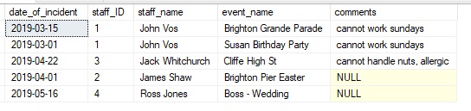

## For all staff acting as supervisors, ensure that a level 3 food hygiene certificate is in place

CREATE TRIGGER supervisors_hygiene_cert

ON tbl_staff_booking

FOR

INSERT

AS

DECLARE

@supervisor_hygiene int,

@staff_role varchar(10),

@staff_ID int

SELECT @staff_ID = staff_ID FROM inserted

SELECT @staff_role = staff_role FROM inserted

SELECT @supervisor_hygiene = food_hygiene_certificate FROM tbl_staff

WHERE staff_ID = @staff_ID

IF @staff_role LIKE 'supervisor' AND @supervisor_hygiene != 3

BEGIN

PRINT('food hygiene certificate level 3 is needed to be a supervisor')

ROLLBACK TRANSACTION

END

INSERT INTO tbl_staff_booking(staff_ID, booking_ID, staff_hours, staff_role)

VALUES

(1, 3, 6, 'supervisor');

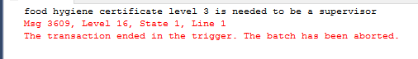

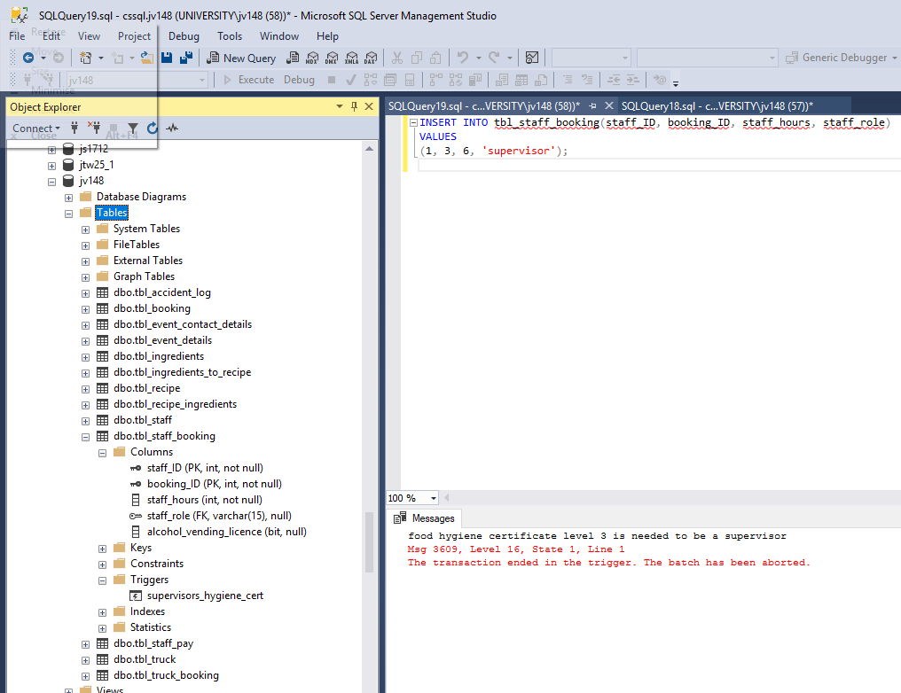

## For all events involving alcohol, identify a team member as the license holder.

CREATE TRIGGER alcohol_license_present

ON tbl_staff_booking

FOR INSERT

AS

BEGIN

DECLARE

@staff_ID int,

@booking_ID int,

@event_ID int,

@license_needed bit,

@alcohol_vending_license_present bit,

@alcohol_staff_license_holder bit,

@count int = 0

SELECT @staff_ID = staff_ID FROM inserted

SELECT @booking_ID = booking_ID FROM inserted

SELECT @event_ID = event_ID FROM tbl_booking WHERE booking_ID = @booking_ID

SELECT @alcohol_staff_license_holder = alcohol_vending_licence FROM inserted

SELECT @license_needed = alcohol_present FROM tbl_event_details

SELECT @alcohol_staff_license_holder = alcohol_vending_licence FROM tbl_staff

SELECT @count = COUNT(alcohol_vending_licence) FROM tbl_staff_booking WHERE booking_ID = @booking_ID AND alcohol_vending_licence != NULL

if @license_needed = 1 AND (@alcohol_staff_license_holder != 1 OR @alcohol_vending_license_present !=1) AND @count <1

BEGIN

PRINT('at least 1 alcohol license holder is needed for the event')

ROLLBACK TRANSACTION

END

END

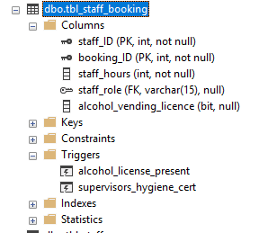

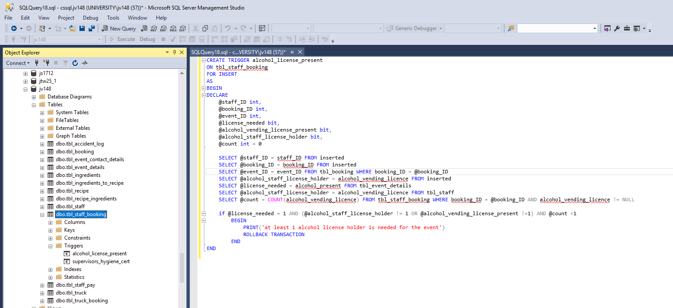

## Identify any temporary staff who are not currently working this weekend (i.e. may be available for a last- minute booking).

SELECT staff_ID, staff_first_name + ' ' + staff_second_name AS NAME, staff_email, food_hygiene_certificate, alcohol_vending_licence

FROM tbl_staff

WHERE NOT EXISTS(

SELECT *

FROM tbl_staff_booking

INNER JOIN tbl_booking

ON tbl_booking.booking_ID = tbl_staff_booking.staff_ID

WHERE tbl_staff.staff_ID = tbl_staff_booking.staff_ID

AND booking_date BETWEEN '2019-03-15' AND '2019-05-16'

)

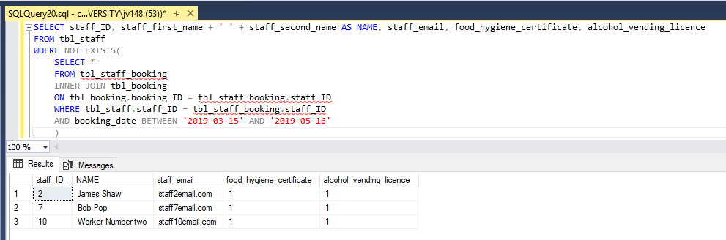

# Could:

## Record members of staff who worked at specific events, including who was acting as the supervisor. This should include the number of hours worked by each staff member, and their rate of pay.

SELECT tbl_staff.staff_ID, staff_first_name + ' ' + staff_second_name AS staff_name, tbl_staff_pay.staff_role, tbl_staff_booking.staff_hours,

tbl_staff_pay.rate_of_pay, staff_hours*rate_of_pay AS salary

FROM tbl_staff

INNER JOIN tbl_staff_booking

ON tbl_staff.staff_ID = tbl_staff_booking.staff_ID

INNER JOIN tbl_staff_pay

ON tbl_staff_pay.staff_role = tbl_staff_booking.staff_role

WHERE booking_ID = 1

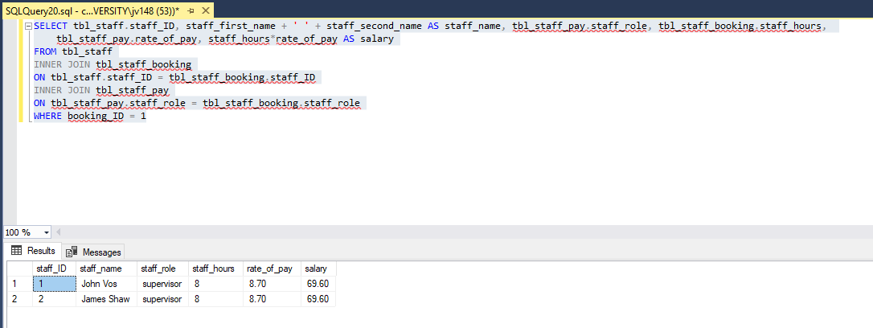

SELECT tbl_staff.staff_ID, staff_first_name + ' ' + staff_second_name AS staff_name, tbl_staff_pay.staff_role, tbl_staff_booking.staff_hours,

tbl_staff_pay.rate_of_pay, staff_hours*rate_of_pay AS salary

FROM tbl_staff

INNER JOIN tbl_staff_booking

ON tbl_staff.staff_ID = tbl_staff_booking.staff_ID

INNER JOIN tbl_staff_pay

ON tbl_staff_pay.staff_role = tbl_staff_booking.staff_role

WHERE booking_ID = 2

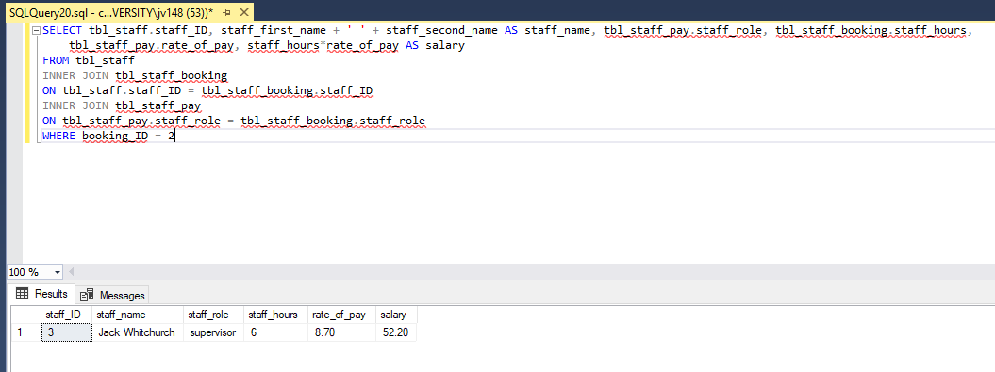

## Produce a list of ingredients for each item sold, with known allergens at the top of the list - this should include sub-ingredients, like the tahini ingredients on the hummus recipe described previously.

SELECT tbl_recipe_ingredients.ingredient_ID, ingredient, contains_allergen

FROM tbl_ingredients

INNER JOIN tbl_recipe_ingredients

ON tbl_recipe_ingredients.ingredient_ID = tbl_ingredients.ingredient_ID

WHERE recipe_ID = 'HF1'

UNION

SELECT DISTINCT sub.ingredient_ID, sub.ingredient, sub.contains_allergen

FROM tbl_ingredients main

JOIN tbl_ingredients sub

ON sub.ingredient_ID= main.ingredient_ID

WHERE main.ingredient_ID

IN(

SELECT ingredient_ID

FROM tbl_recipe_ingredients

WHERE recipe_ID = 'HF1'

)

ORDER BY contains_allergen DESC

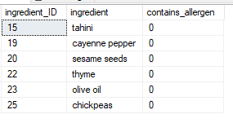

# Would be nice if:

## Identify weekends in the next month with available trucks (to offer last minute deals)

DECLARE

@date date,

@booking_ID varchar(4),

@booking_date date

SET @date = CONVERT(DATE, '2019-05-01')

; WITH tbl_truck_booking AS

(

SELECT

@date AS [date],

DATENAME (MONTH, @date) AS [month],

DATENAME (DW, @date) AS [day],

@booking_ID AS [booking],

@booking_date AS [booking date]

UNION ALL

SELECT

DATEADD(DAY, 1, [date]) AS [date],

DATENAME (MONTH,DATEADD(DAY, 1, [date])) AS [month],

DATENAME (DW ,DATEADD(DAY, 1, [date])) AS [day],

@booking_ID AS [booking ID],

@booking_date AS [booking date]

FROM

tbl_truck_booking

WHERE

YEAR(DATEADD(DAY, 1 ,[date]) ) = YEAR(@Date)

AND MONTH(DATEADD(DAY, 1, [date])) = MONTH(@Date)

)

SELECT *

FROM tbl_truck_booking

WHERE [Day] IN ('Saturday', 'Sunday')

ORDER BY [DATE]

OPTION (MAXRECURSION 367)

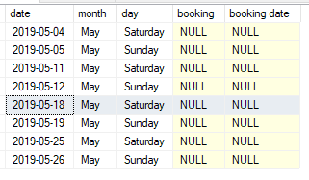

# Functionality:

## PART 1)

A stored procedure is required that will create a new booking using parameters giving the details of the date and length of event in days, a named contact and the total number of workers required.

CREATE PROCEDURE add_booking

@booking_ID int,

@event_ID int,

@booking_name varchar(50),

@booking_date date,

@booking_duration int,

@repeat_event bit

AS

DECLARE @errors int

INSERT INTO tbl_booking(booking_ID, event_ID, booking_name, booking_date, booking_duration, repeat_event)

VALUES

(@booking_ID, @event_id, @booking_name, @booking_date, @booking_duration, @repeat_event)

SET @errors = @@ERROR

IF @errors <> 0

RETURN 99

ELSE

RETURN 00

GO

## PART 2)

A stored procedure is required to produce a list of bookings and staff members (identifying the supervisor) for the forthcoming month.

CREATE PROCEDURE bookings_per_month

AS

BEGIN

SELECT tbl_booking.booking_ID, booking_date, staff_first_name, staff_second_name, staff_role

FROM tbl_booking

INNER JOIN tbl_staff_booking

ON tbl_staff_booking.booking_ID = tbl_booking.booking_ID

INNER JOIN tbl_staff

ON tbl_staff_booking.staff_ID = tbl_staff.staff_ID

WHERE booking_date BETWEEN GETDATE() AND DATEADD(MONTH, 1, GETDATE())

END

GO

RETURN

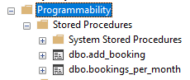

## PART 3)

A trigger is required that is actioned when a booking is cancelled. This will produce all staff who are booked to be working at this event, with their contact details so that that they can be alerted to change.

CREATE TRIGGER booking_cancelation_prompt

ON tbl_booking

INSTEAD OF DELETE

AS

DECLARE

@deleted_booking_ID int

SELECT @deleted_booking_ID = booking_ID FROM deleted

BEGIN

SELECT staff_first_name, staff_second_name, staff_email

FROM tbl_staff

INNER JOIN tbl_staff_booking

ON tbl_staff_Booking.staff_ID = tbl_staff.staff_ID

WHERE booking_ID = @deleted_booking_ID

DELETE FROM tbl_truck_booking

WHERE booking_ID = @deleted_booking_ID

DELETE FROM tbl_staff_booking

WHERE booking_ID = @deleted_booking_ID

DELETE FROM tbl_booking

WHERE booking_ID = @deleted_booking_ID

END

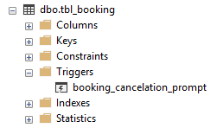

# Create a simple application to provide an interface capable of executing the above functionality (select queries and procedures):

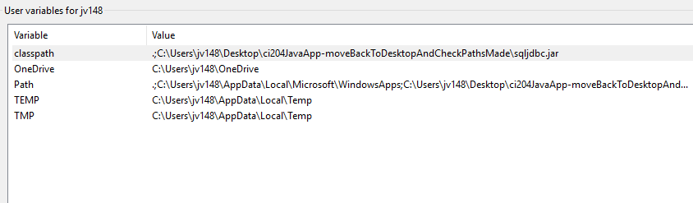

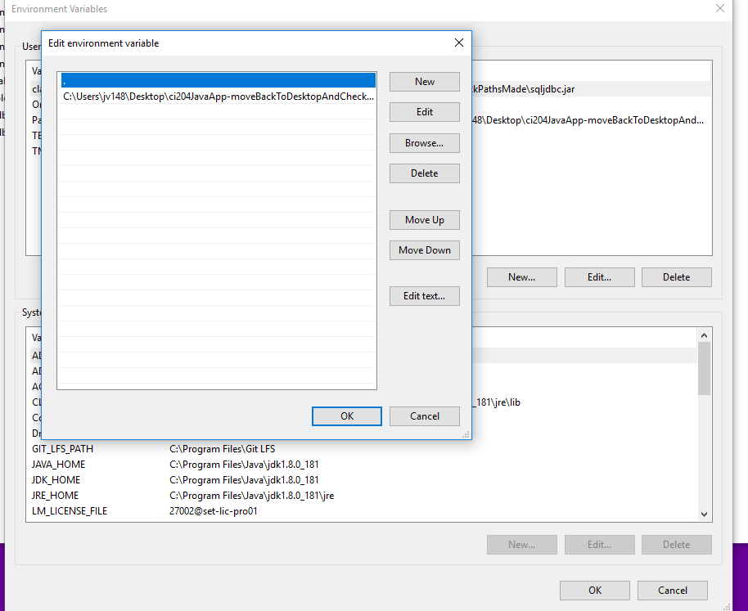

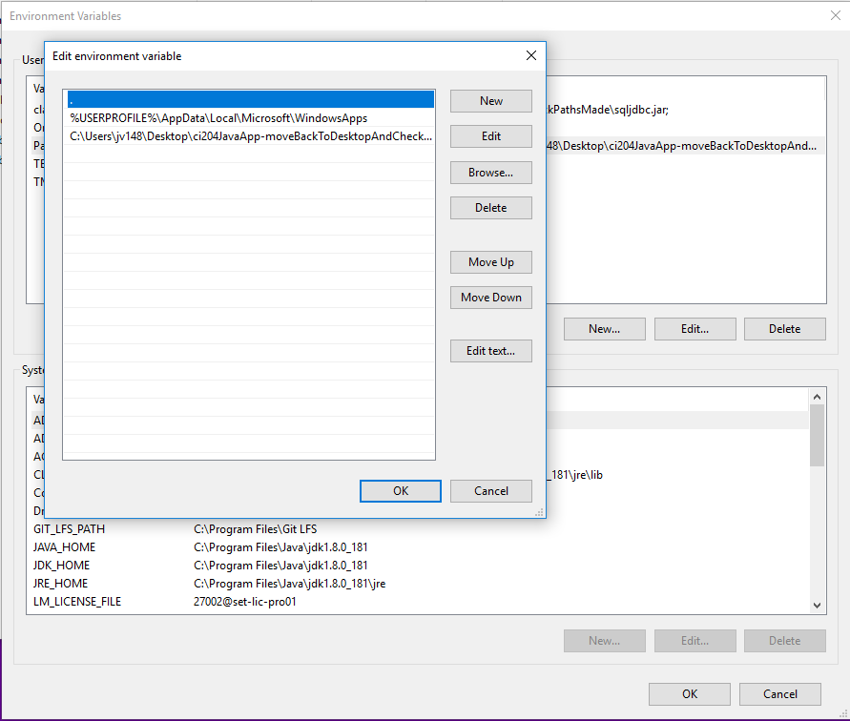

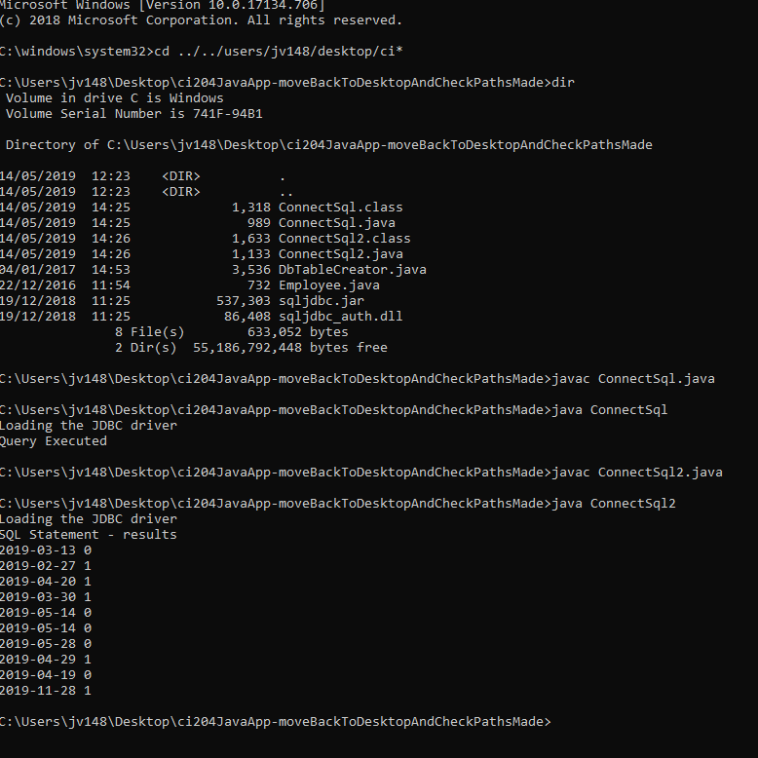

# ERD:

